NC Item Summary

Path : Reports >> NC Item Summary.

Steps to reach NC Item Summary:
Step 1 : Reports in Steps to reach NC Item Summary : Open the Reports module from the Billing Application(POS).
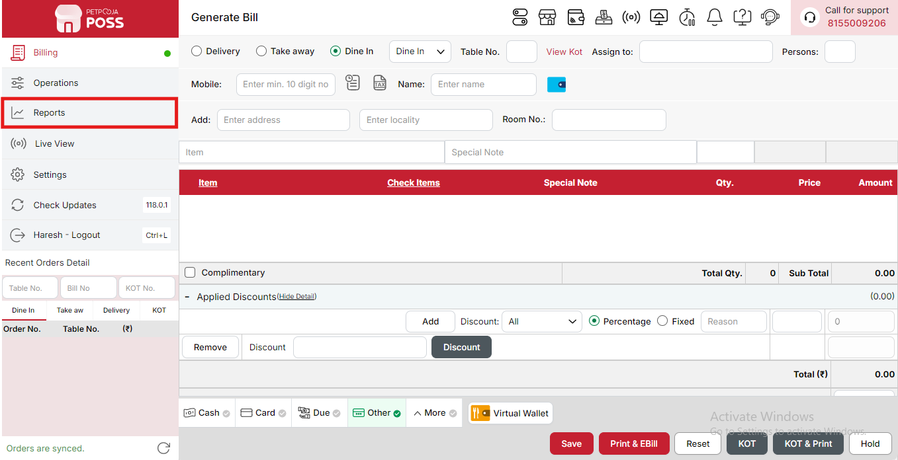
{Image Name: Reports Option,
Description: The red box highlights the “Reports” option in the sidebar menu. This section allows users to view and analyze various business reports, such as sales, billing, and order summaries, helping in effective tracking and decision-making.Here is an image of Step 1 Report in Steps to Reach NC Item Summary.}
Step 2 : NC Item Summary in Steps to reach NC Item Summary : Select NC Item Summary to view a summary of non-compliant or special category items, including quantities sold, revenue, and any applicable adjustments.
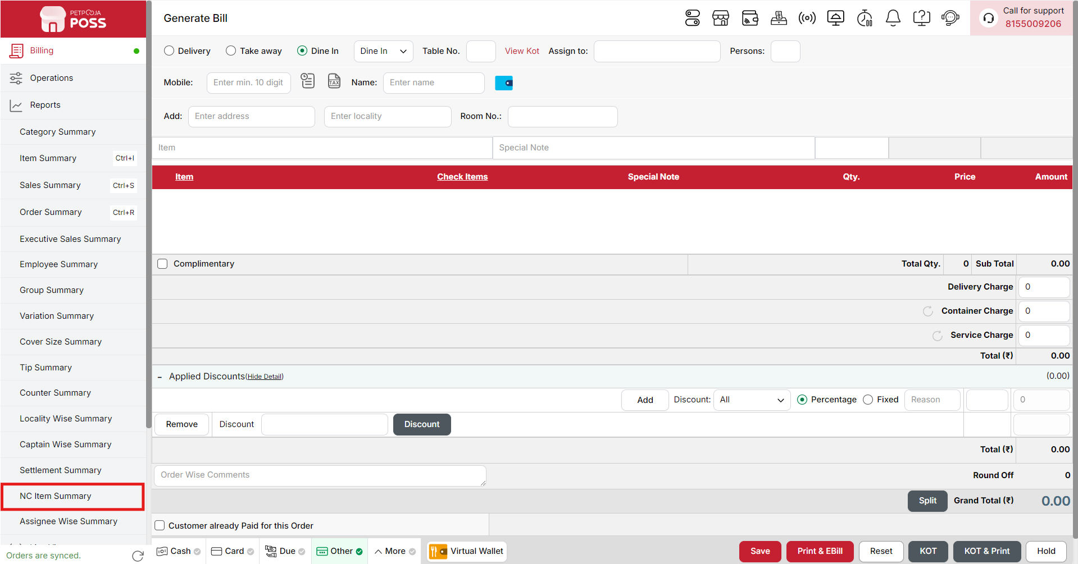
{Image Name: NC Item Summary,
Description: The red box highlights the NC Item Summary option under the Reports section. This report tracks all “No Charge” or complimentary items processed during billing, helping management monitor free or discounted dishes and prevent misuse or revenue leakage.Here is an image of Step 2 NC Item Summary in Steps to Reach NC Item Summary.}

Key features of NC Item Summary :
(NC Item Summary) Note: If you are not able to see or use the NC Item Summary option in your billing application, it means that you do not have the required permission. To enable this, you need to go to the Owner Dashboard and open the User Management section. Inside User Management, you will find a permission called NC Item Summary Show Button — you must checkmark this option to give access.If you are not able to view old day reports, then you also need to enable the Days Restriction permission. Inside the same User Management section, select No Restriction so that you can view reports for any date.After allowing these permissions, perform a manual sync so the system updates the rights properly. Once the sync is done, log out from the billing application and then log in again. After this process, the NC Item Summary option will become visible, and you will be able to view all reports without any problem.

- (NC Item Summary) NC Item Summary: Displays a summary of all items marked as No Charge on the selected date. This helps management monitor complimentary or voided items and ensure accountability.
- (NC Item Summary) Date: Shows the date and time when the NC transaction was recorded, helping track when the free or voided items were processed.
- (NC Item Summary) Invoice No.: Displays the invoice number linked to each NC transaction, making it easy to trace the original order.
- (NC Item Summary) Item Name: Lists the name of the item marked as No Charge, helping identify which products were given without charge.
- (NC Item Summary) Qty.: Shows the total quantity of each item provided as NC, useful for inventory and stock tracking.
- (NC Item Summary) Menu Price (₹): Represents the standard price of a single unit of the item as per the menu.
- (NC Item Summary) Menu Price Total (₹): Calculates the total menu value for all NC items (Menu Price × Quantity), showing the potential revenue if the items were sold.
- (NC Item Summary) NC Price (₹): Displays the price assigned to the NC item, if applicable, for accounting purposes.
- (NC Item Summary) NC Price Total (₹): Shows the total NC amount for all items marked as No Charge, helping assess the financial impact.
- (NC Item Summary) NC Reason: Indicates the justification for marking the item as No Charge, such as testing, complimentary offers, or customer service recovery.
- (NC Item Summary) Biller: Displays the name or ID of the user who processed the NC transaction, helping track staff accountability.
- (NC Item Summary) NC Date: Shows the exact timestamp when the NC transaction was finalized or recorded.
- (NC Item Summary) Total: Represents the overall summary for the selected date, including total quantity, total menu price, and total NC value.
Search Button (NC Item Summary) : The Search button is used to find the report for a specific date or time. It helps you quickly see sales details for the selected period. After choosing the date or time, you can click on Search to view the report.
- From (NC Item Summary) : The From option is used to select the starting date for the NC Item report. It means the report will begin from this date.
- To (NC Item Summary) : The To option is used to select the ending date for the NC Item report. It means the report will show data up to this date.
- Time Wise Option (NC Item Summary) : The Time Wise Option is used when you want to see the report for a specific time period within a day. After turning it ON, you can choose both date and time — for example, from 10:00 AM to 5:00 PM — to see sales during that time. If you keep this option OFF (Without Time Wise Option), then the report will show the whole day’s data for the selected date range without filtering by time.
Configure Column (NC Item Summary) : Used to show or hide different columns in the report by checking or unchecking the boxes. If you want to see that option in the report, you have to check it, and if you want to hide it, you have to uncheck it.
- (Configure Column) Invoice No.: Shows the invoice number associated with the NC (No Charge) item. You can check this to display it in the report or uncheck it to hide it.
- (Configure Column) Item Name: Shows the name of the item that was marked as NC (No Charge). You can check this to show it in the report or uncheck it to hide it.
- (Configure Column) Qty.: Shows the quantity of NC items. You can check this to view the quantity in the report or uncheck it to hide it.
- (Configure Column) Menu Price (₹): Shows the regular menu price of a single NC item. You can check this to see it in the report or uncheck it to hide it.
- (Configure Column) Menu Price Total (₹): Shows the total menu price of all NC items based on their quantity. You can check this to view it in the report or uncheck it to hide it.
- (Configure Column) NC Price (₹): Shows the NC price (usually ₹0) assigned to the item. You can check this to display it in the report or uncheck it to hide it.
- (Configure Column) NC Price Total (₹): Shows the total NC price for all items combined. You can check this to view total NC value or uncheck it to hide it.
- (Configure Column) NC Reason: Shows the reason why the item was marked as NC (No Charge). You can check this to display the reason in the report or uncheck it to hide it.
- (Configure Column) Biller: Shows the name of the biller who processed the NC item. You can check this to display it in the report or uncheck it to hide it.
- (Configure Column) NC Date: Shows the date when the item was marked as NC. You can check this to view it in the report or uncheck it to hide it.
(NC Item Summary) Print Button: The Print Button is used to print the report. If you want to take a printout of the report, you just need to click on the Print button.
If you get an error saying “Please assign one printer for report print”, then follow these steps:
- Go to Operation → Bill/KOT Print → Multiple Printer Settings.
- Select and edit one printer that you want to use for printing the report.
- In that printer setting, there is an option called “Use this printer for report print”.
- Check this box and save the setting.
After doing this, you will be able to print the report successfully using the selected printer.

(NC Item Summary) Print Configuration: This section is used to set how your report will look when you print it. You can change the format, size, and what details to show on the printed page.
- (Print Configuration) Show Bill Header: If you check this option, the header (top part with company or shop name) will appear on the print.
- (Print Configuration) Show Bill Footer: If you check this option, the footer (bottom part with notes or messages) will appear on the printed report.
- (Print Configuration) NONE: Select this option if you don’t want to apply any specific print format or layout. The report will print in the default basic format without additional formatting or sections.
- (Print Configuration) Display To Date on Print: If you check this option, the “To Date” of the report will be shown on the printed page.
- (Print Configuration) Display Time on Print: If you check this option, the time will be displayed on the print along with the date.
- (Print Configuration) Display Summary Box on Print: If you check this option, a summary box will appear at the end of the report showing total amounts and other summary details.
- (Print Configuration) Display Print Date & Time on Print: If you check this option, the date and time when the report was printed will appear on the print.
- (Print Configuration) Main Width: Used to set the width of the report on the printed page. For example, 500 means the report will be printed with that width size.
- (Print Configuration) Font Size: Used to set the text size of the printed report. You can increase or decrease it as needed.
- (Print Configuration) Cancel: Click this button to close the print configuration window without saving any changes.
- (Print Configuration) Save:Click this button to save all the changes you made in the print configuration settings.
(NC Item Summary) Export Excel: If you want to download or save the report in Excel format, you have to click on the Export Excel button. This will create an Excel file of the report that you can open and use in Microsoft Excel.

